**Lab No: 7 Form Processing using Django – Part I**

**Name: Ketan Goud**

**Reg No: 220905260**

**Section: D D2**

**Roll No: 39**

**Develop a Web Application for Grocery Checklist Generation as shown in the figure below. It must have checkboxes which must be populated on page load listing grocery items. On clicking the Add Item button the selected Items and their prices have to be displayed in a Table. Set the borderstyle and border width for the table and its cells.**

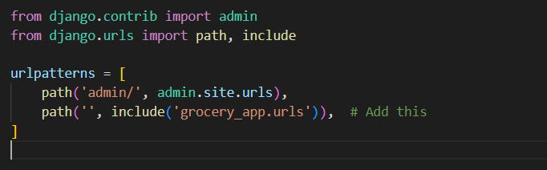

<!DOCTYPE html>

<html lang="en">

<head>

    <meta charset="UTF-8">

    <meta name="viewport" content="width=device-width, initial-scale=1.0">

    <title>Grocery Checklist</title>

    <style>

        body {

            font-family: Arial, sans-serif;

            background-color: #f8f9fa;

            margin: 20px;

            text-align: center;

        }

        .container {

            max-width: 500px;

            margin: auto;

            padding: 20px;

            background: white;

            border-radius: 10px;

            box-shadow: 0px 4px 8px rgba(0,0,0,0.1);

        }

        h1 {

            color: #343a40;

        }

        form {

            text-align: left;

        }

        input[type="checkbox"] {

            margin-right: 10px;

        }

        button {

            background: #007bff;

            color: white;

            padding: 10px;

            border: none;

            border-radius: 5px;

            cursor: pointer;

        }

        button:hover {

            background: #0056b3;

        }

        table {

            width: 100%;

            margin-top: 20px;

            border-collapse: collapse;

        }

        table, th, td {

            border: 2px solid #343a40;

            padding: 10px;

            text-align: left;

        }

        th {

            background: #343a40;

            color: white;

        }

        .total {

            font-size: 1.2rem;

            font-weight: bold;

            margin-top: 10px;

        }

    </style>

</head>

<body>

    <div class="container">

        <h1>Grocery Checklist</h1>

        <form method="post">

            {% csrf_token %}

            {{ form.as_p }}

            <button type="submit">Add Item</button>

        </form>

        {% if cart %}

        <table>

            <tr>

                <th>Item</th>

                <th>Price (₹)</th>

            </tr>

            {% for item in cart %}

            <tr>

                <td>{{ item.name }}</td>

                <td>{{ item.price }}</td>

            </tr>

            {% endfor %}

        </table>

        <p class="total">Total Price: ₹{{ total_price }}</p>

        {% endif %}

    </div>

</body>

</html>

